KUBERNETES Task-01
Task 1: Setup Minikube on Local Machine
We'll assume your local machine is Windows + Docker Desktop.
Step 1: Check Docker
Open PowerShell:
docker --version
Then:
docker ps
You should get something like:
Docker version 28.x.x
and:
CONTAINER ID IMAGE COMMAND ...
If Docker is not running, start Docker Desktop.
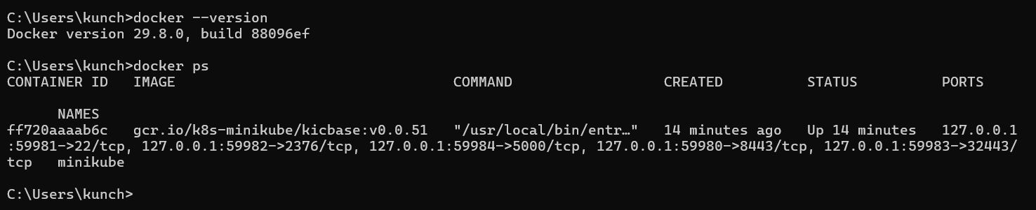

Step 2: Install Minikube
Download Minikube for Windows from the official Kubernetes Minikube project.
Minikube official documentation
After installation:
minikube version
Expected:
minikube version: v...

Step 3: Start Minikube
Because you're using Docker Desktop:
minikube start --driver=docker
Wait for:
Done! kubectl is now configured to use "minikube" cluster
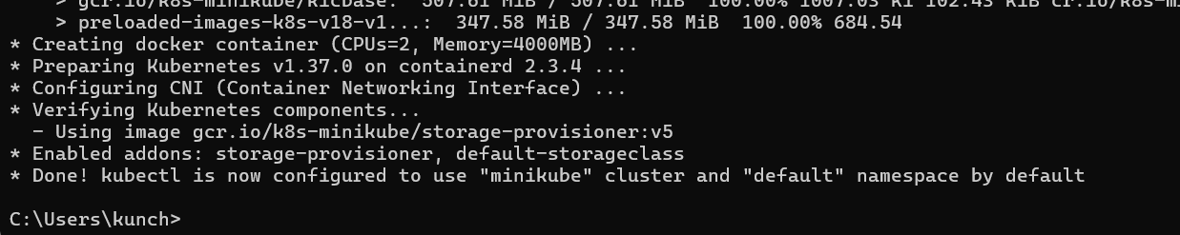

Step 4: Check Minikube
minikube status
Expected:
host: Running
kubelet: Running
apiserver: Running
kubeconfig: Configured
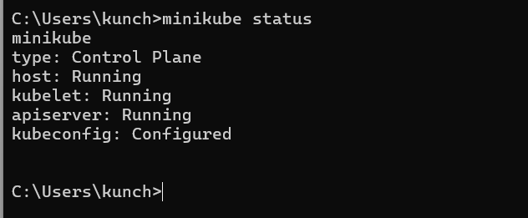

Step 5: Check Kubernetes Nodes
kubectl get nodes
Expected:
NAME STATUS ROLES AGE VERSION
minikube Ready control-plane ... v...
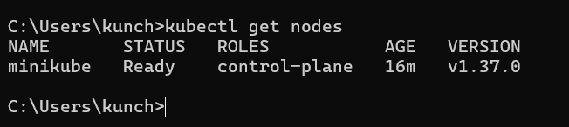
Remember
Minikube
↓
Creates Kubernetes cluster
↓
Usually one-node cluster
↓
Used mainly for local learning/testing

Task 2 — Create the AWS EC2 instance
Step 1 — Instance type
You are currently on this screen.
Select:
Instance type → t3.small
You should see:
- Family: t3
- vCPU: 2
- Memory: 2 GiB
- Free tier eligible ✅
Do not select t3.medium.

Step 2 — Key pair
Scroll down to Key pair (login).
You will see something like:
Key pair — Required
If you already have a key pair, select your existing .pem key.
For example:
venu-k8s-key
If you don't have one:
- Click Create new key pair
- Key pair name:
k8s-task2-key
- Key pair type:
RSA
- Private key file format:
.pem
- Click Create key pair
Your .pem file will download.
⚠️ Keep this file safe. Do not delete it.
AWS's EC2 launch wizard requires/strongly recommends a key pair when you need SSH access.

Step 3 — Network settings
Scroll to Network settings.
For a simple Kubernetes practice EC2:
VPC
Select your existing/default VPC.
For example:
vpc-xxxxxxxx
Subnet
Select a subnet in the same VPC.
For example:
ap-south-2a
Auto-assign Public IP
Set:
Enable
We need a public IP so you can connect to the server.

Step 4 — Security Group
Under Firewall / Security group, select:
Create security group
Security group name:
k8s-task2-sg
Description:
Security Group for Kubernetes Task 2
Add these inbound rules.
SSK 22 MY IP
Important
For SSH:
SSH
Port 22
Source → My IP
Do not unnecessarily use 0.0.0.0/0 for SSH.
The other ports depend on exactly what your Task 2 Kubernetes application requires. For a basic Kubernetes lab, we can tighten these rules later.
AWS describes security groups as the virtual firewall controlling inbound and outbound traffic to the instance.

Step 5 — Configure storage
Scroll down to Configure storage.
You should see something similar to:
1 × 8 GiB gp3
For our practice server, you can use:
8 GiB gp3
If your Kubernetes task involves Docker images and several containers, I would prefer:
20 GiB gp3
But 8 GiB is okay for a basic lab.

Step 6 — Advanced details
Don't change anything here for now.
Keep the default settings.

Step 7 — Launch
At the right side/bottom, click:
Launch instance
You should get a message similar to:
Successfully initiated launch of instance
Then click:
View all instances

Step 8 — Wait for all 3 instances
Go to:
AWS Console → EC2 → Instances
You should see:
Instance | Type | State
k8s-master | t3.small | Running
k8s-worker1 | t3.small | Running
k8s-worker2 | t3.small | Running
Wait until each instance shows:
Status check: 3/3 checks passed ✅
Don't connect while the status is still Initializing.

Step 9 — Rename the instances
Let's make the three nodes easy to identify.
Instance 1
Select:
i-039430a1a3935f0af
Change Name to:
k8s-master
Instance 2
Select:
i-02ec138eb860653cf
Change Name to:
k8s-worker1
Instance 3
Select:
i-0f9000788f4e2d0f0
Change Name to:
k8s-worker2
You should finally see:
k8s-master
k8s-worker1
k8s-worker2
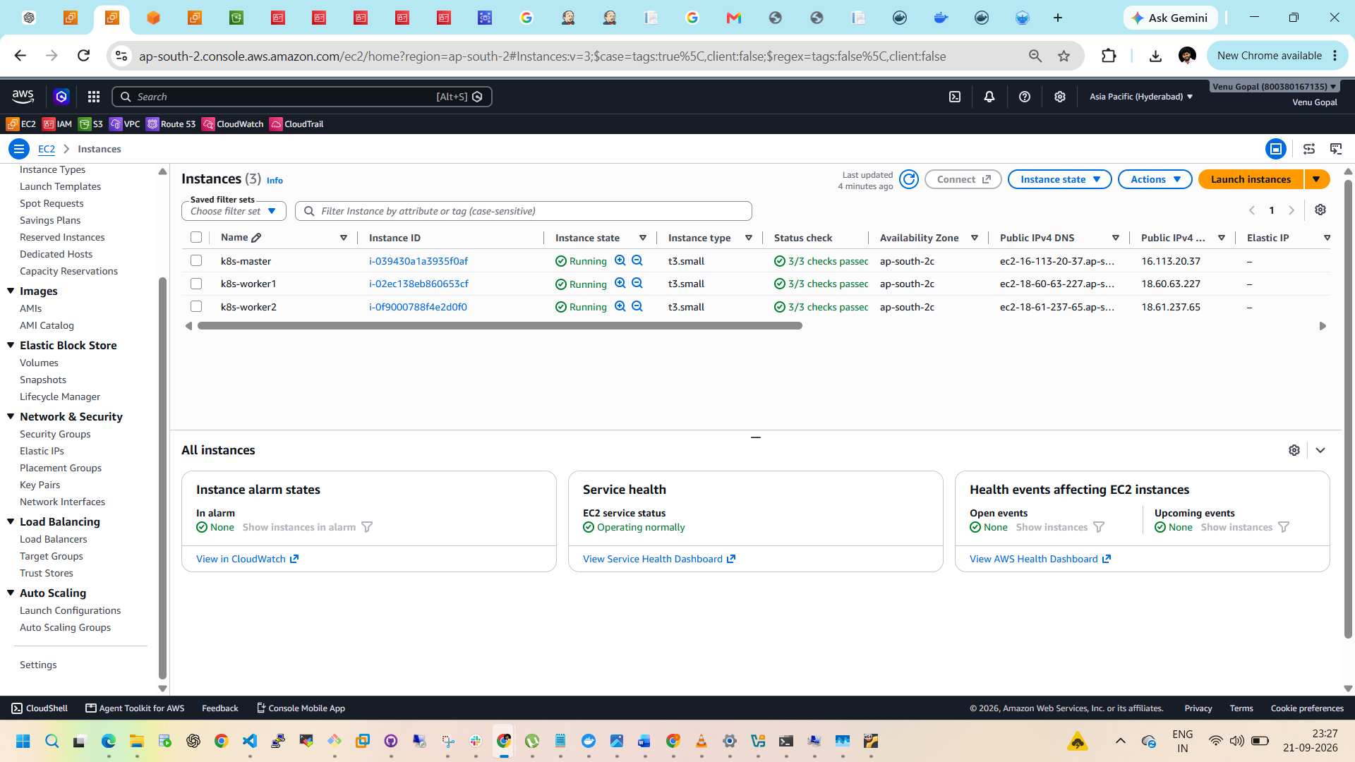

Step 10 — Get the Master's Public IP
Select k8s-master.
Go to Details.
Find:
Public IPv4 address
It will look something like:
16.xxx.xxx.xxx
Keep this IP for your connection.

Step 11 — Connect to k8s-master
Since you're using Windows, let's use EC2 Instance Connect first because it's easier.
Select:
k8s-master
Then:
Connect → EC2 Instance Connect
You should see:
Username:
ubuntu
Then click:
Connect
A browser terminal should open.
Important
If EC2 Instance Connect gives an error, don't change anything yet. Send me the screenshot and I'll guide you.

Step 12 — Verify Ubuntu
Once the terminal opens, run one command at a time.
12.1 Check username
whoami
Expected:
ubuntu
12.2 Check OS
cat /etc/os-release
We want to see:
Ubuntu
and preferably:
VERSION_ID="24.04"
12.3 Check hostname
hostname
It may not yet say k8s-master. That's okay—we'll configure the hostname shortly.
12.4 Check CPU
nproc
Expected:
2
12.5 Check RAM
free -h
You should see approximately 2 GiB.
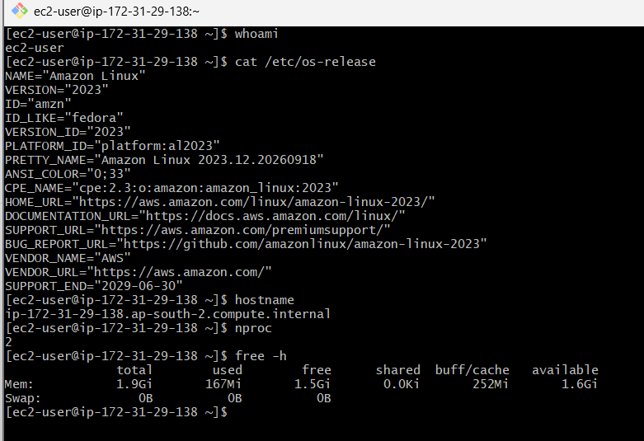

Your Step 13 should therefore be
sudo dnf update -y
Wait until it finishes and you get your prompt back:
[ec2-user@ip-172-31-29-138 ~]$
Then verify:
sudo dnf --version
You should see the DNF version.
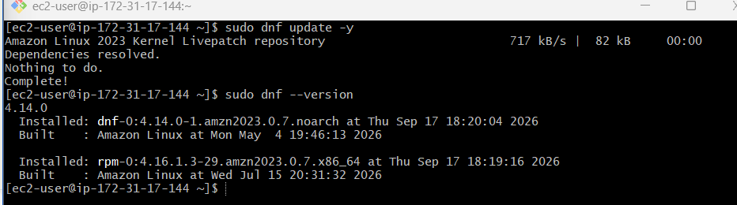
Your Step 14
Then run:
df -h
You already successfully completed these checks:
whoami → ec2-user ✅
OS → Amazon Linux 2023 ✅
hostname → k8s-master host ✅
nproc → 2 ✅
memory → 1.9 GiB ✅
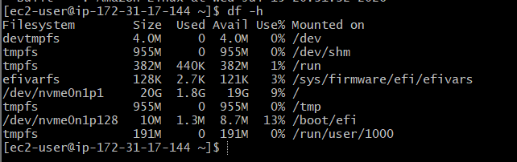

Step 15 — Disable swap
Your earlier output showed:
Swap: 0B 0B 0B
So swap is already disabled. We still need to make sure it won't be enabled after reboot.
Run:
sudo swapon --show
If it returns nothing, that's good.
Then check /etc/fstab:
cat /etc/fstab
If there is a swap entry, we'll disable it. Don't edit it yet—send me the output first.
Step 15 status
Swap currently enabled? → NO ✅
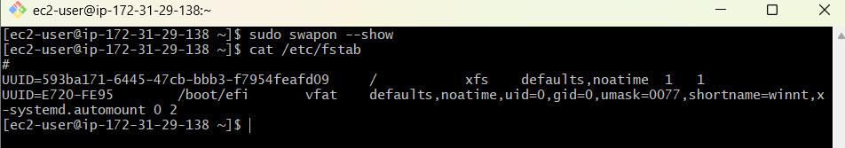

Step 16 — Install container runtime
Your original material says Docker, but for a current kubeadm Kubernetes cluster, we'll use containerd as the CRI runtime rather than installing Docker + cri-dockerd.
Run:
sudo dnf install -y containerd
Then:
containerd –version
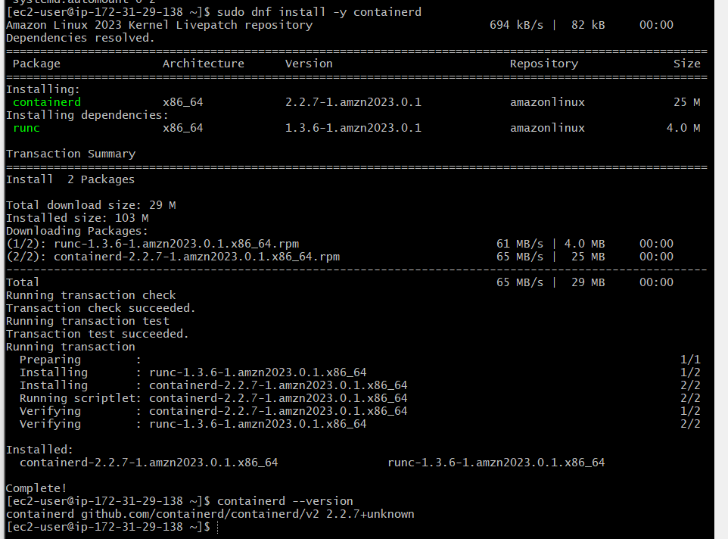

Step 17 — Configure containerd
Run:
sudo mkdir -p /etc/containerd
Then:
sudo containerd config default | sudo tee /etc/containerd/config.toml
Enable systemd cgroups:
sudo sed -i 's/SystemdCgroup = false/SystemdCgroup = true/' /etc/containerd/config.toml
Restart:
sudo systemctl restart containerd
Enable at boot:
sudo systemctl enable containerd
Check:
sudo systemctl status containerd
You want:
Active: active (running)
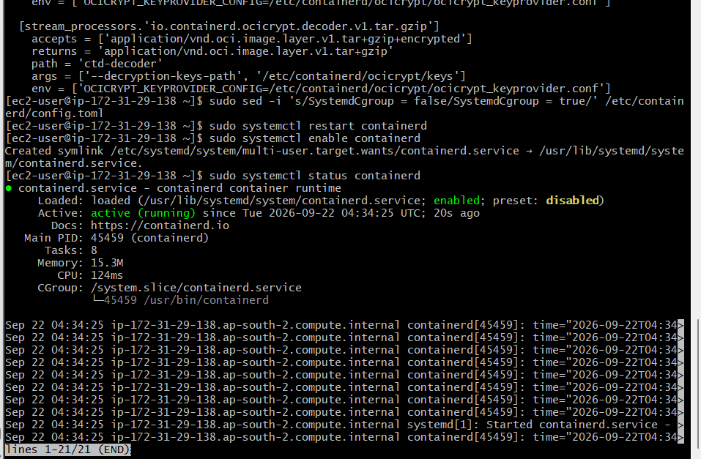
Continue with Step 18 — Install Kubernetes tools
We'll use the current Kubernetes repository, rather than the old Google Kubernetes repository from many older tutorials. The current Kubernetes documentation uses pkgs.k8s.io; the current stable documentation is for Kubernetes 1.37.
Step 18.1 — Create Kubernetes repository
Run this entire block:
cat <<EOF | sudo tee /etc/yum.repos.d/kubernetes.repo
[kubernetes]
name=Kubernetes
baseurl=https://pkgs.k8s.io/core:/stable:/v1.37/rpm/
enabled=1
gpgcheck=1
gpgkey=https://pkgs.k8s.io/core:/stable:/v1.37/rpm/repodata/repomd.xml.key
exclude=kubelet kubeadm kubectl cri-tools kubernetes-cni
EOF
You should see the repository configuration printed.
Step 18.2 — Install kubelet, kubeadm and kubectl
Run:
sudo dnf install -y kubelet kubeadm kubectl --disableexcludes=kubernetes
This installs:
- kubeadm → creates/joins the cluster
- kubelet → Kubernetes node agent
- kubectl → command-line tool for managing Kubernetes
The official Kubernetes installation instructions use these three packages.
Step 18.3 — Enable kubelet
Run:
sudo systemctl enable --now kubelet
Then:
sudo systemctl status kubelet
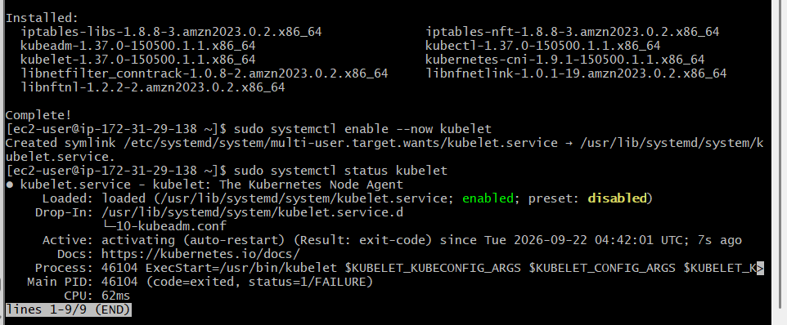
⚠️ Don't worry if kubelet isn't fully running yet.
Before kubeadm init, kubelet may repeatedly restart because the cluster hasn't been initialized yet. That's normal during this stage.
Step 18.4 — Verify versions
Run:
kubeadm version
Then:
kubectl version --client
Then:
kubelet --version
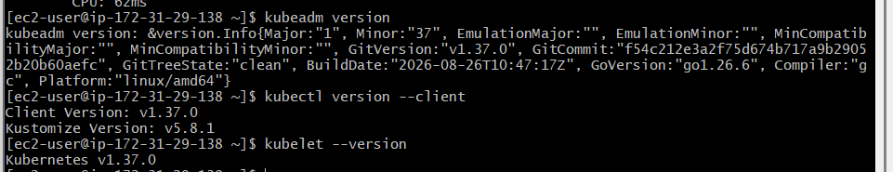
Step 19 — Initialize the Kubernetes control plane
Before running kubeadm init, let's make sure the required kernel/network settings are enabled.
Run these commands one by one:
19.1 Load required kernel modules
sudo modprobe overlay
sudo modprobe br_netfilter
19.2 Configure Kubernetes networking
sudo tee /etc/sysctl.d/k8s.conf <<EOF
net.bridge.bridge-nf-call-iptables = 1
net.bridge.bridge-nf-call-ip6tables = 1
net.ipv4.ip_forward = 1
EOF
Apply the settings:
sudo sysctl --system
You should see the three settings being applied.
19.3 Verify IP forwarding
Run:
sysctl net.ipv4.ip_forward
Expected:
net.ipv4.ip_forward = 1
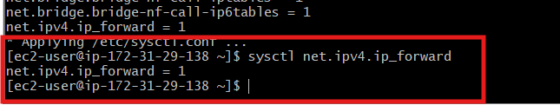

Step 20 — Initialize the master
Now we'll use your training command:
sudo kubeadm init --pod-network-cidr=10.244.0.0/16
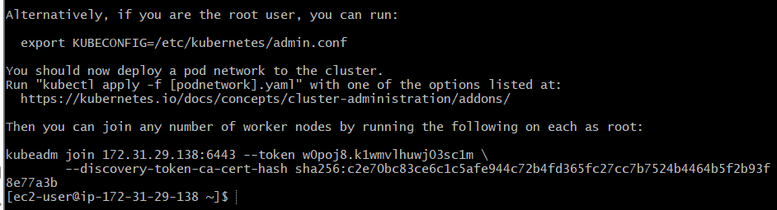

Step 21 — Configure kubectl for the master
Run these exactly:
mkdir -p $HOME/.kube
Then:
sudo cp -i /etc/kubernetes/admin.conf $HOME/.kube/config
If it asks:
overwrite /home/ec2-user/.kube/config?
type:
y
Then:
sudo chown $(id -u):$(id -g) $HOME/.kube/config
Step 22 — Check the cluster
Now run:
kubectl get nodes
You will probably see something like:
NAME STATUS ROLES AGE
ip-172-31-29-138... NotReady control-plane ...
NotReady is expected at this point because we haven't installed the Flannel CNI yet.
Then run:
kubectl get pods -A
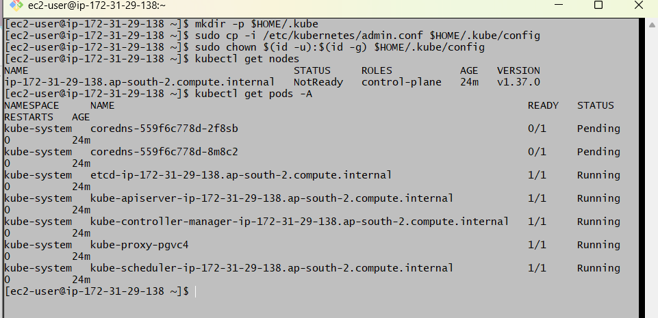
Step 23 — Install Flannel CNI
You are currently on the k8s-master server.
Run:
kubectl apply -f https://github.com/flannel-io/flannel/releases/latest/download/kube-flannel.yml
You should see resources being created, for example:
namespace/kube-flannel created
serviceaccount/flannel created
clusterrole.rbac.authorization.k8s.io/flannel created
...
daemonset.apps/kube-flannel-ds created
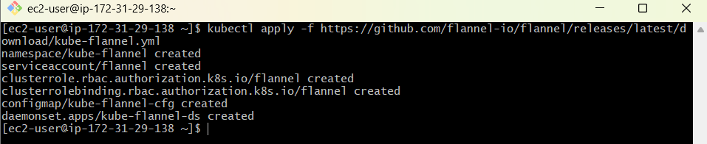
Step 23.1 — Check Flannel pods
Wait about 30–60 seconds, then run:
kubectl get pods -A
Look for:
kube-flannel
It should eventually show:
1/1 Running
Step 23.2 — Check master status
Then run:
kubectl get nodes
Previously you had:
STATUS
NotReady
After Flannel is working, we want:
STATUS
Ready
For example:
NAME STATUS ROLES AGE
ip-172-31-29-138.ap-south-2.compute.internal Ready control-plane ...
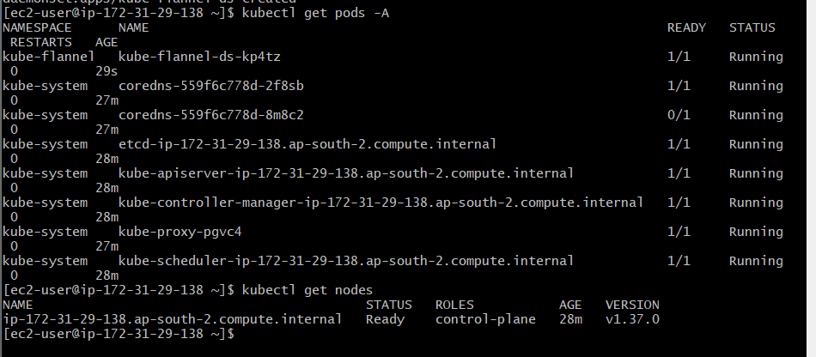
Step 23.3 — Check all system pods
Finally:
kubectl get pods -A
The CoreDNS pods that were previously:
0/1 Pending
should start becoming:
1/1 Running
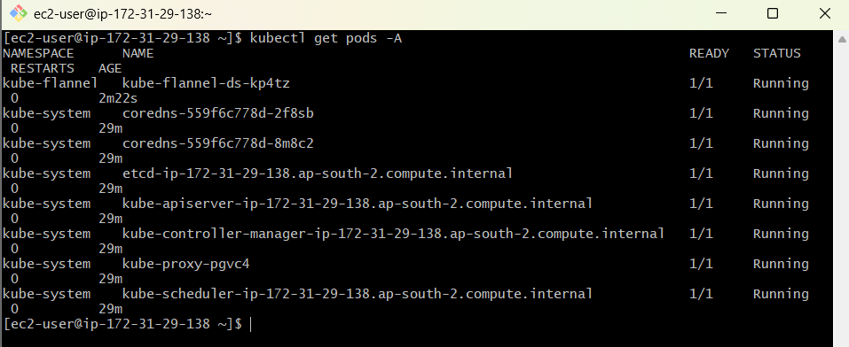
Step 24 — Launch k8s-worker1 and k8s-worker2
We need:
Kubernetes Cluster
|
+---------+---------+
| |
k8s-worker1 k8s-worker2
Your current master:
k8s-master
Private IP: 172.31.29.138
Status: Ready
24.1 Launch Worker 1
Go to:
AWS Console → EC2 → Instances → Launch instance
Use the same configuration as the master:
Name
k8s-worker1
AMI
Select:
Amazon Linux 2023
Instance type
Use:
t3.small
Don't use t3.medium, since your account is not showing it as Free Tier eligible.
Key pair
Use the same key pair you used for k8s-master.
For example:
k8s-task2-key
Network
Use the same VPC as the master:
vpc-03c01e1b9b2a03a0e
Use the same subnet or another subnet in the same VPC.
Public IP
Set:
Enable
Security Group
Use the same:
k8s-task2-sg
This is important because the worker must communicate with the master.
Storage
Use:
20 GiB gp3
Then click:
Launch instance
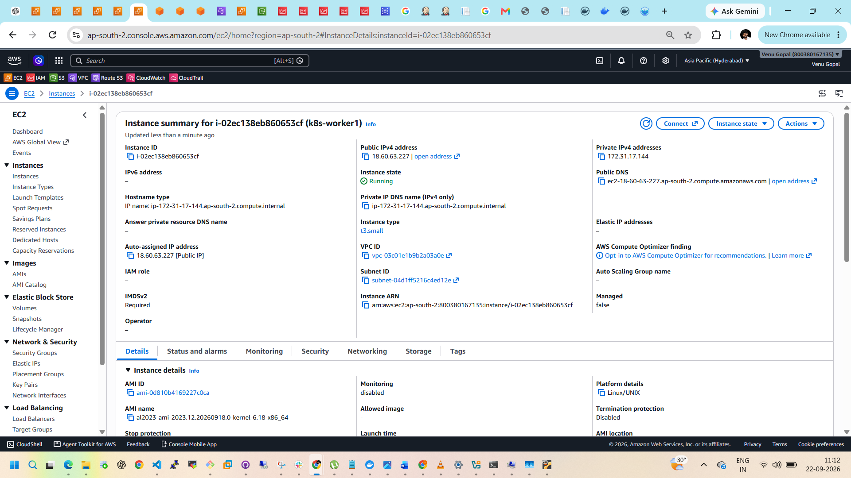

24.2 Launch Worker 2
Repeat exactly the same configuration.
Name:
k8s-worker2
Use:
Amazon Linux 2023
t3.small
same key pair
same VPC
same Security Group
20 GiB gp3
Public IP enabled
Launch it.
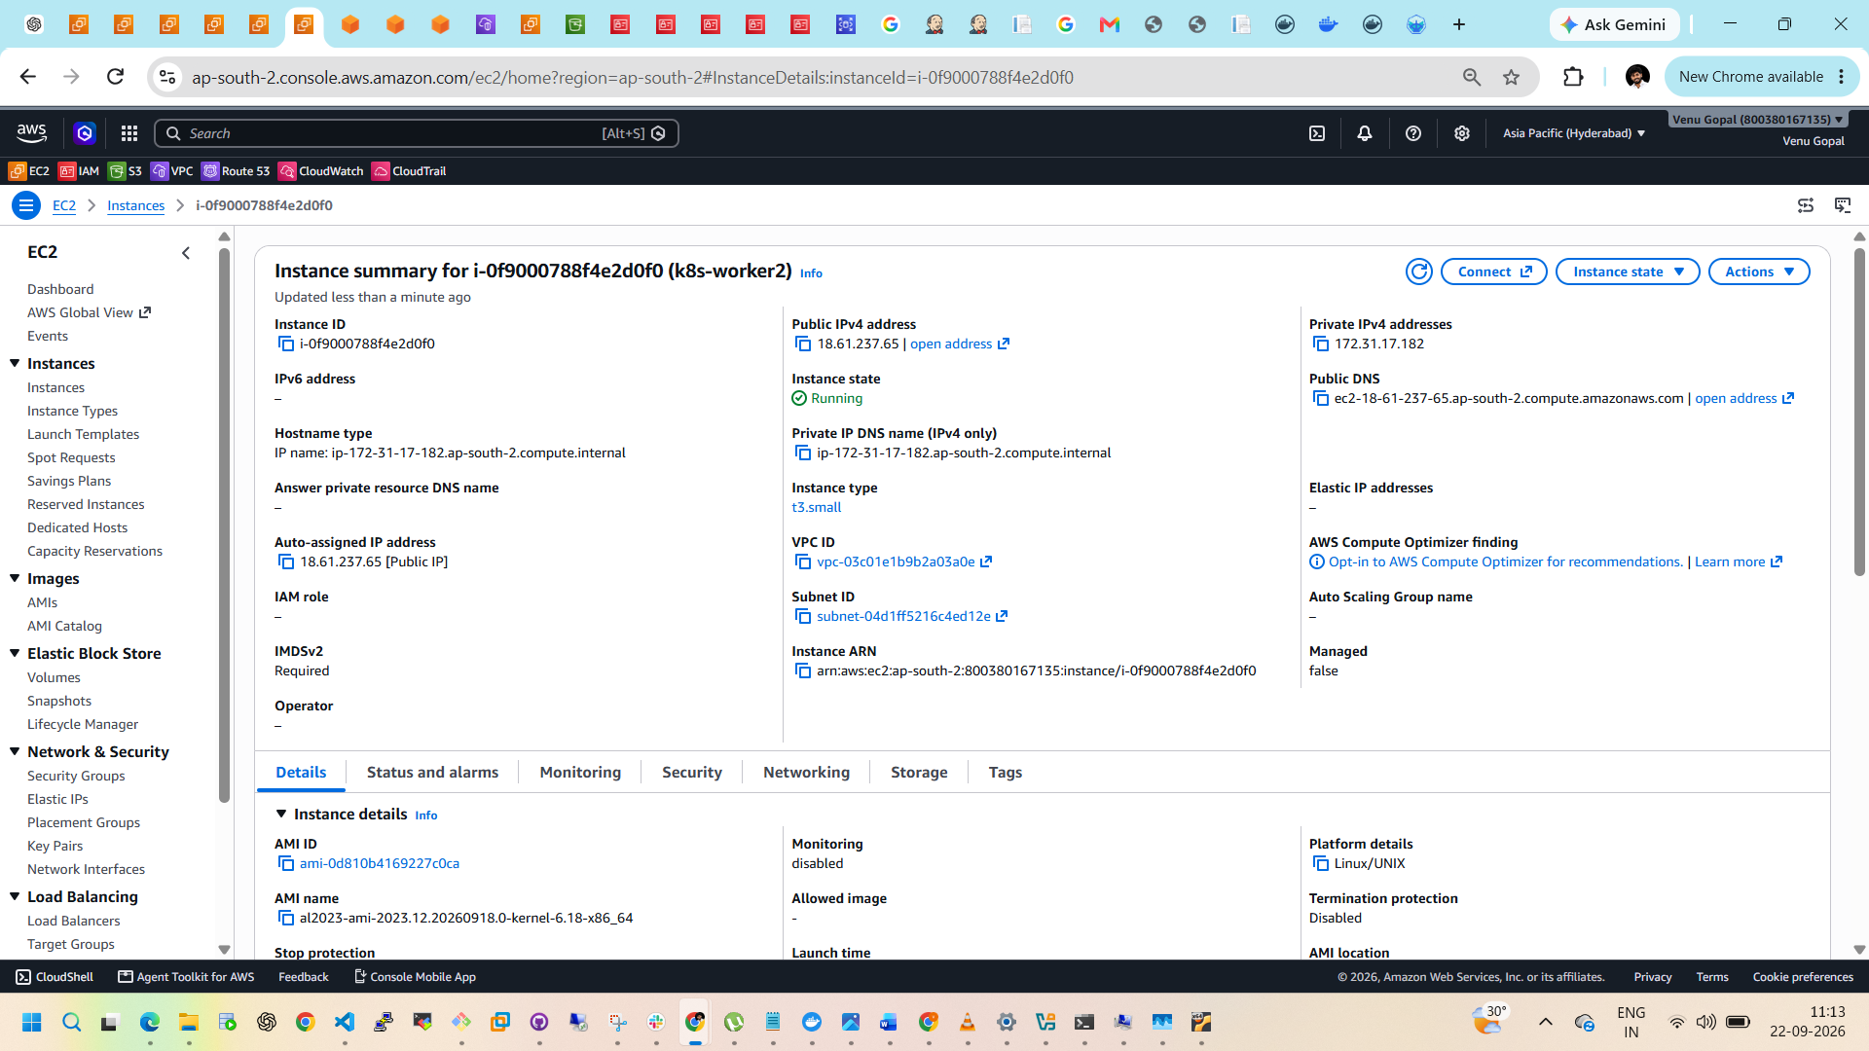

24.3 Verify all 3 instances
You should now have:
Instance | OS | Type | Purpose
k8s-master | Amazon Linux 2023 | t3.small | Control plane
k8s-worker1 | Amazon Linux 2023 | t3.small | Worker
k8s-worker2 | Amazon Linux 2023 | t3.small | Worker
Wait until both workers show:
Running
and their status checks are passed.

24.4 Connect to Worker 1
From Git Bash:
ssh -i ~/Downloads/YOUR-KEY.pem ec2-user@WORKER1_PUBLIC_IP
Replace:
YOUR-KEY.pem
with your actual key filename.
Replace:
WORKER1_PUBLIC_IP
with Worker 1's public IP.
For example:
ssh -i ~/Downloads/k8s-task2-key.pem ec2-user@xx.xx.xx.xx

24.5 Prepare Worker 1
Once connected to Worker 1, verify:
whoami
Expected:
ec2-user
Then:
cat /etc/os-release
Confirm:
Amazon Linux 2023
Then update:
sudo dnf update -y
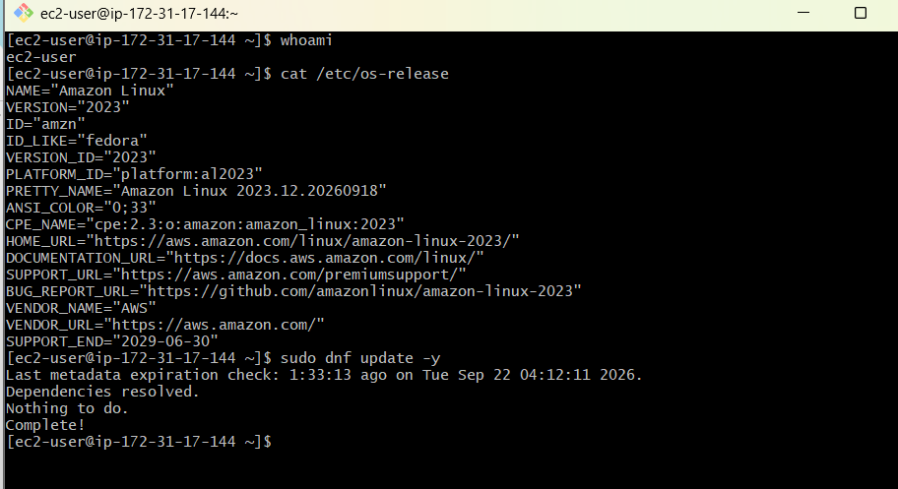

24.6 Install containerd on Worker 1
Run:
sudo dnf install -y containerd
Then:
sudo mkdir -p /etc/containerd
sudo containerd config default | sudo tee /etc/containerd/config.toml
Enable systemd cgroups:
sudo sed -i 's/SystemdCgroup = false/SystemdCgroup = true/' /etc/containerd/config.toml
Restart:
sudo systemctl restart containerd
Enable:
sudo systemctl enable containerd
Check:
sudo systemctl status containerd
You want:
Active: active (running)
Press:
q
to exit the status screen.
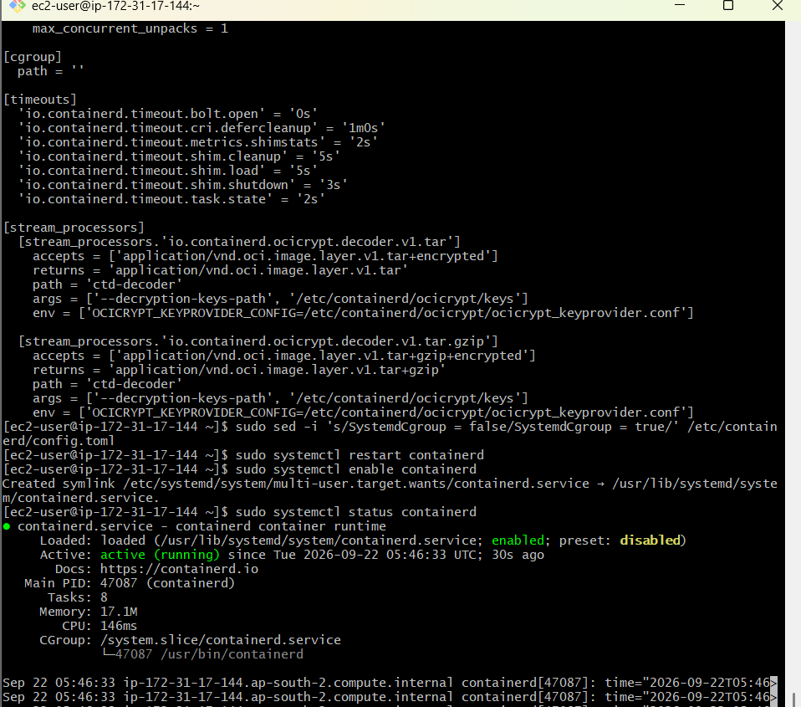

24.7 Install Kubernetes packages on Worker 1
Create the same Kubernetes repository:
cat <<EOF | sudo tee /etc/yum.repos.d/kubernetes.repo
[kubernetes]
name=Kubernetes
baseurl=https://pkgs.k8s.io/core:/stable:/v1.37/rpm/
enabled=1
gpgcheck=1
gpgkey=https://pkgs.k8s.io/core:/stable:/v1.37/rpm/repodata/repomd.xml.key
exclude=kubelet kubeadm kubectl cri-tools kubernetes-cni
EOF
Install:
sudo dnf install -y kubelet kubeadm kubectl --disableexcludes=kubernetes
Enable kubelet:
sudo systemctl enable --now kubelet
Verify:
kubeadm version
kubelet --version
You should have:
v1.37.0
matching your master.
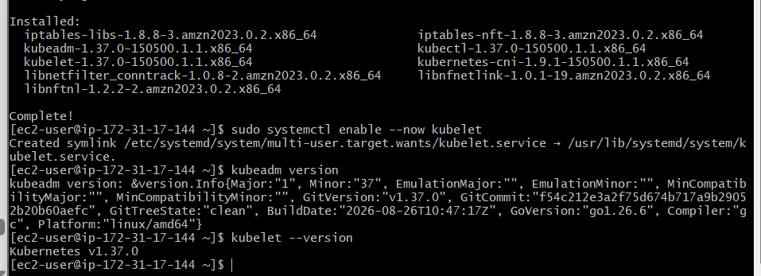

24.8 Configure Kubernetes networking on Worker 1
Run:
sudo modprobe overlay
sudo modprobe br_netfilter
Then:
sudo tee /etc/sysctl.d/k8s.conf <<EOF
net.bridge.bridge-nf-call-iptables = 1
net.bridge.bridge-nf-call-ip6tables = 1
net.ipv4.ip_forward = 1
EOF
Apply:
sudo sysctl --system
Verify:
sysctl net.ipv4.ip_forward
Expected:
net.ipv4.ip_forward = 1
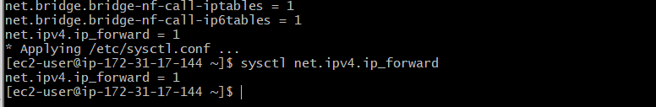

24.9 Worker 1 is now prepared
At this point do not run kubeadm init on Worker 1.
Workers use:
kubeadm join
not:
kubeadm init

Step 24.10 — Prepare k8s-worker2
Connect to k8s-worker2 from Git Bash.
ssh -i ~/Downloads/YOUR-KEY.pem ec2-user@WORKER2_PUBLIC_IP
Replace the key filename and Worker 2 public IP with yours.

Step 24.10.1 — Verify Worker 2
Run:
whoami
Expected:
ec2-user
Then:
cat /etc/os-release
Confirm:
Amazon Linux 2023
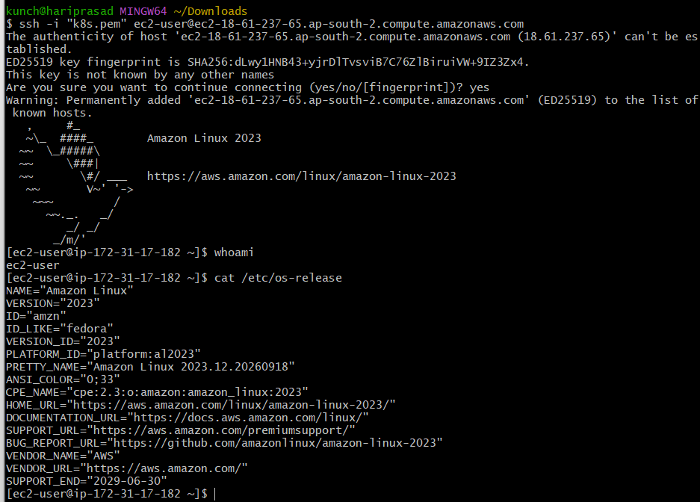

Step 24.10.2 — Update Worker 2
sudo dnf update -y
Then check swap:
free -h
You want:
Swap: 0B 0B 0B
Also check:
sudo swapon --show
If nothing is returned, swap is disabled. ✅
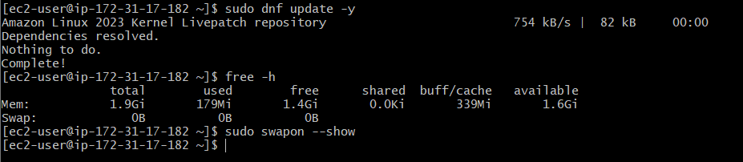

Step 24.10.3 — Install containerd
sudo dnf install -y containerd
Check:
containerd –version
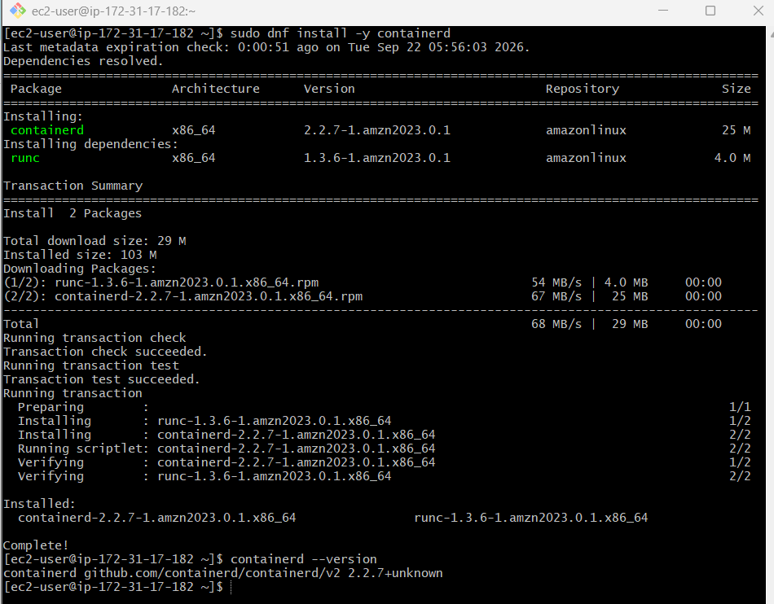

Step 24.10.4 — Configure containerd
Create the configuration directory:
sudo mkdir -p /etc/containerd
Generate the configuration:
sudo containerd config default | sudo tee /etc/containerd/config.toml
Enable systemd cgroups:
sudo sed -i 's/SystemdCgroup = false/SystemdCgroup = true/' /etc/containerd/config.toml
Restart containerd:
sudo systemctl restart containerd
Enable it at boot:
sudo systemctl enable containerd
Check:
sudo systemctl status containerd
You need:
Active: active (running)
If you see the (END) screen, press:
q
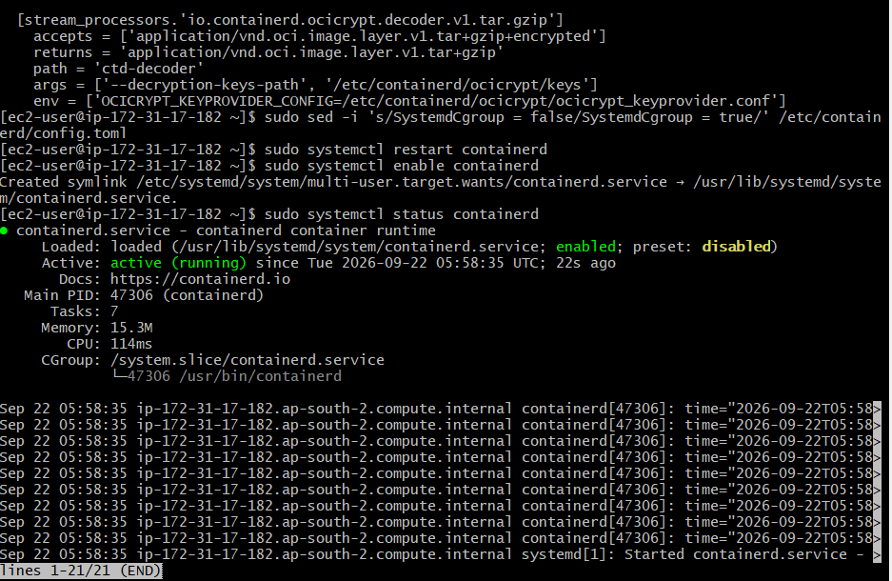

Step 24.10.5 — Install Kubernetes repository
Run:
cat <<EOF | sudo tee /etc/yum.repos.d/kubernetes.repo
[kubernetes]
name=Kubernetes
baseurl=https://pkgs.k8s.io/core:/stable:/v1.37/rpm/
enabled=1
gpgcheck=1
gpgkey=https://pkgs.k8s.io/core:/stable:/v1.37/rpm/repodata/repomd.xml.key
exclude=kubelet kubeadm kubectl cri-tools kubernetes-cni
EOF

Step 24.10.6 — Install Kubernetes components
Run:
sudo dnf install -y kubelet kubeadm kubectl --disableexcludes=kubernetes
Enable kubelet:
sudo systemctl enable --now kubelet
Check versions:
kubeadm version
kubelet --version
kubectl version --client
They should show:
v1.37.0
matching your master.
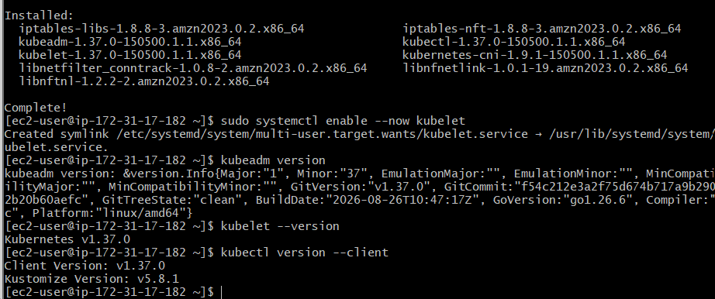

Step 24.10.7 — Configure Kubernetes networking
Load the required modules:
sudo modprobe overlay
sudo modprobe br_netfilter
Create the Kubernetes networking configuration:
sudo tee /etc/sysctl.d/k8s.conf <<EOF
net.bridge.bridge-nf-call-iptables = 1
net.bridge.bridge-nf-call-ip6tables = 1
net.ipv4.ip_forward = 1
EOF
Apply:
sudo sysctl --system
Verify:
sysctl net.ipv4.ip_forward
Expected:
net.ipv4.ip_forward = 1
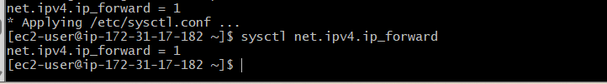

Step 24.10.8 — Worker 2 is ready
At this point, do NOT run:
kubeadm init
on Worker 2.
The worker will join the existing cluster using:
kubeadm join

Step 25 — Generate a fresh Worker Join command
On k8s-master, run:
kubeadm token create --print-join-command
It will produce a new command.
Do not run that command on the master.

Step 26 — Join Worker 1
Connect to k8s-worker1 through Git Bash:
ssh -i ~/Downloads/YOUR-KEY.pem ec2-user@WORKER1_PUBLIC_IP
Once you are on Worker 1, verify:
hostname
Then run the complete command generated by the master, with sudo in front.
It will look like:
sudo kubeadm join 172.31.29.138:6443 --token <TOKEN> --discovery-token-ca-cert-hash sha256:<HASH>
Expected successful result
You should see something similar to:
This node has joined the cluster:
* Certificate signing request was sent to and approved by kubelet...
* The Kubelet was informed of the new secure connection details.
The exact output can vary.
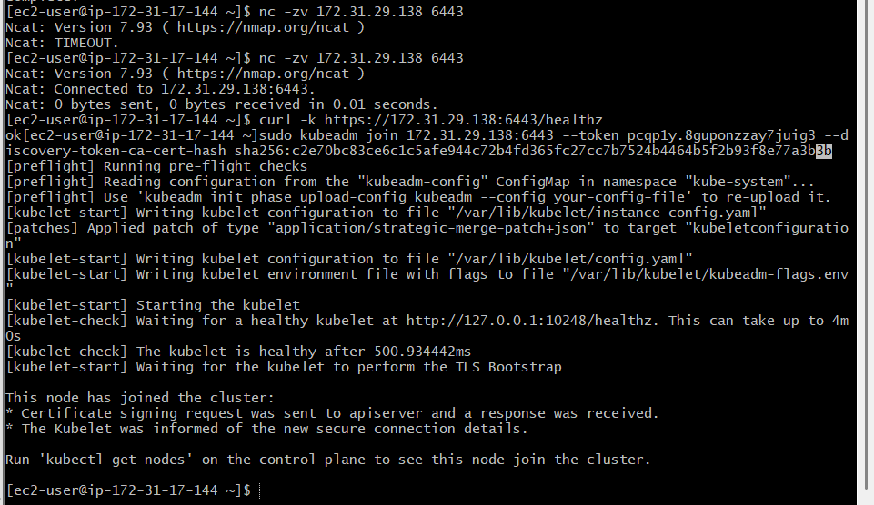

Step 27 — Join Worker 2
Exit Worker 1:
exit
Connect to Worker 2:
ssh -i ~/Downloads/YOUR-KEY.pem ec2-user@WORKER2_PUBLIC_IP
Then run the same fresh complete kubeadm join command:
sudo kubeadm join 172.31.29.138:6443 --token <TOKEN> --discovery-token-ca-cert-hash sha256:<HASH>
You should again receive a successful join message.
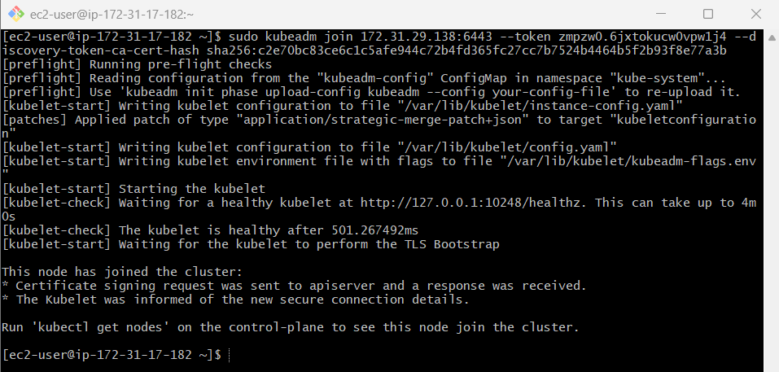

Step 28 — Verify all 3 nodes
Return to the master:
exit
Then:
ssh -i ~/Downloads/YOUR-KEY.pem ec2-user@MASTER_PUBLIC_IP
Run:
kubectl get nodes
Initially, workers may show NotReady for a short time.
Wait about 30–60 seconds and run:
kubectl get nodes
The final result should look approximately like:
NAME STATUS ROLES VERSION
ip-172-31-29-138.ap-south-2.compute.internal Ready control-plane v1.37.0
ip-172-31-xx-xx.ap-south-2.compute.internal Ready <none> v1.37.0
ip-172-31-xx-xx.ap-south-2.compute.internal Ready <none> v1.37.0
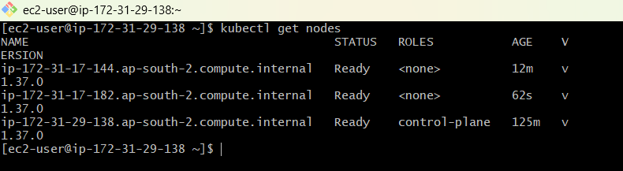
Step 29 — Kubernetes Cluster Health Verification
Flannel CNI
All 3 Flannel pods are running:
kube-flannel-ds-kp4tz 1/1 Running
kube-flannel-ds-r8gh8 1/1 Running
kube-flannel-ds-shnm4 1/1 Running
✅ This confirms networking is working on Master + Worker 1 + Worker 2.
CoreDNS
coredns-... 1/1 Running
coredns-... 1/1 Running
✅ Kubernetes DNS is working.
Control Plane
etcd 1/1 Running
kube-apiserver 1/1 Running
kube-controller-manager 1/1 Running
kube-scheduler 1/1 Running
✅ Master/control-plane components are healthy.
kube-proxy
You have 3 kube-proxy pods:
kube-proxy-g94r4 1/1 Running
kube-proxy-pgvc4 1/1 Running
kube-proxy-r84fd 1/1 Running
✅ kube-proxy is running on all 3 nodes.
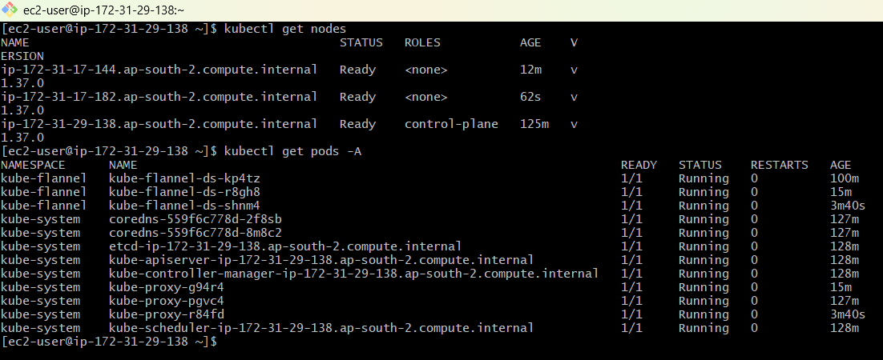

Step 30 — Final Cluster Verification
Run this on the Master:
kubectl get nodes -o wide
Then:
kubectl cluster-info
Finally:
kubectl get pods -A 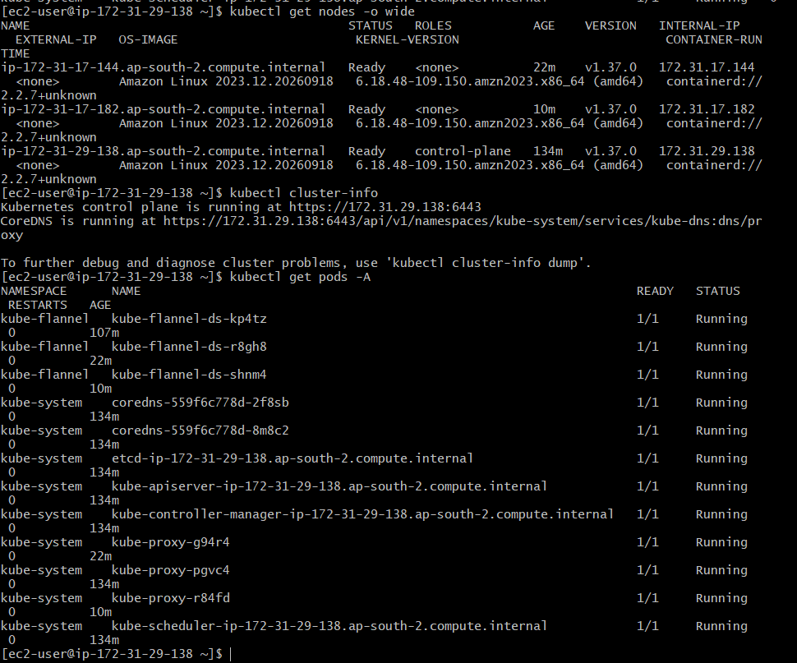
Your current output already shows:
12/12 Kubernetes system pods are healthy — no restarts and no failed pods. 🎉
Your final architecture
AWS VPC
172.31.0.0/16
│
│
┌─────────▼─────────┐
│ K8s Master │
│ 172.31.29.138 │
│ Control Plane │
└─────────┬─────────┘
│
Flannel Network
10.244.0.0/16
┌──────┴──────┐
│ │
┌───────▼──────┐ ┌────▼─────────┐
│ Worker 1 │ │ Worker 2 │
│172.31.17.144 │ │172.31.17.182 │
│ Ready │ │ Ready │
└──────────────┘ └──────────────┘

🟢 Task 3 — Run One NGINX Pod
Now we'll deploy our first application.
Step 3.1 — Create NGINX Pod
Run on master:
kubectl run nginx --image=nginx
Check:
kubectl get pods
Expected:
NAME READY STATUS RESTARTS AGE
nginx 1/1 Running 0 ...
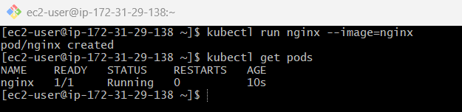

Step 3.2 — Get More Information
kubectl get pod -o wide
You might see:
NAME READY STATUS IP NODE
nginx 1/1 Running 0 k8s-worker1
This tells you which worker node is running the pod.
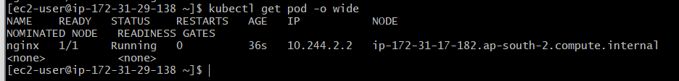

Step 3.3 — Describe Pod
kubectl describe pod nginx
Very important for interviews.

Step 3.4 — Check NGINX Inside Pod
kubectl exec -it nginx -- /bin/bash
Inside container:
nginx -v
Then:
exit
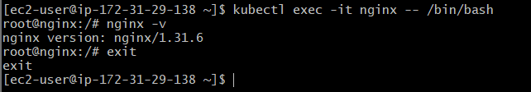

Task 4 — Kubernetes Master & Worker Components
Step 1 — Verify your 3-node cluster
You are currently on the Master:
ip-172-31-29-138
Run:
kubectl get nodes
You should see your 3 nodes:
NAME STATUS ROLES
ip-172-31-17-144.ap-south-2.compute.internal Ready <none>
ip-172-31-17-182.ap-south-2.compute.internal Ready <none>
ip-172-31-29-138.ap-south-2.compute.internal Ready control-plane
✅ This proves your Master + 2 Workers are working.
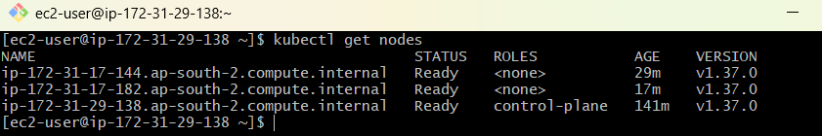

Step 2 — Understand Control Plane Components
Your Master has these components:
CONTROL PLANE
│
├── kube-apiserver
├── etcd
├── kube-scheduler
└── kube-controller-manager
You already verified them with:
kubectl get pods -n kube-system
Your output showed all of them:
etcd 1/1 Running
kube-apiserver 1/1 Running
kube-controller-manager 1/1 Running
kube-scheduler 1/1 Running
1. kube-apiserver
Think:
API Server = Front Door
When you execute:
kubectl get pods
the request goes approximately:
kubectl
↓
kube-apiserver
↓
Kubernetes
Interview answer:
kube-apiserver is the central entry point for Kubernetes API requests. kubectl communicates with the API Server to interact with the cluster.

2. etcd
Think:
etcd = Database
It stores Kubernetes cluster state and configuration.
For example:
Nodes
Pods
Deployments
Services
Secrets
ConfigMaps
Interview answer:
etcd is Kubernetes' distributed key-value store. It stores the cluster's persistent state and configuration.

3. kube-scheduler
Think:
Scheduler = Chooses the Worker
For example:
New Pod
↓
Scheduler
↓
Worker 1
Interview answer:
The kube-scheduler determines which node should run a newly created Pod based on available resources, constraints, affinity, taints/tolerations, and other scheduling rules.

4. kube-controller-manager
Think:
Controller = Maintains Desired State
Example:
Desired:
3 Pods

Actual:
2 Pods

Controller
↓
Works toward 3 Pods
Interview answer:
The controller manager runs controllers that continuously compare the desired state with the actual state and take actions to reconcile differences.

Step 3 — Understand Worker Components
Your two workers have:
WORKER NODE
│
├── kubelet
├── kube-proxy
└── container runtime
1. kubelet
Think:
kubelet = Worker Node Agent
It communicates with the API Server and makes sure the Pods assigned to the node are running.
Interview answer:
kubelet is the agent running on each node that ensures Pods and their containers are running according to the Pod specifications.

2. kube-proxy
Think:
kube-proxy = Service Networking
It helps implement Kubernetes Service networking rules on the node.
Interview answer:
kube-proxy maintains networking rules that help route traffic to Kubernetes Services and their backend Pods.

3. Container Runtime
Think:
Container Runtime = Actually Runs Containers
Your cluster is using:
containerd
Interview answer:
The container runtime is responsible for running containers. Examples include containerd and CRI-O.

Step 4 — Your Interview Memory Trick 🔥
Memorize this exact sequence:
CONTROL PLANE

API Server → Talks / Entry Point
etcd → Stores
Scheduler → Selects
Controller → Maintains
And:
WORKER

kubelet → Agent
kube-proxy → Networking
containerd → Runs containers
One-line answer
API Server talks, etcd stores, Scheduler selects, Controller maintains, kubelet manages, kube-proxy handles service networking, and the container runtime runs containers.
That's a very good interview memory line.

Step 5 — Verify Your NGINX Pod
You already completed the NGINX test.
Run:
kubectl get pods -o wide
You should see something similar to:
NAME READY STATUS RESTARTS AGE
nginx 1/1 Running 0 ...
Then:
kubectl describe pod nginx
This is useful for understanding which worker is running your Pod.
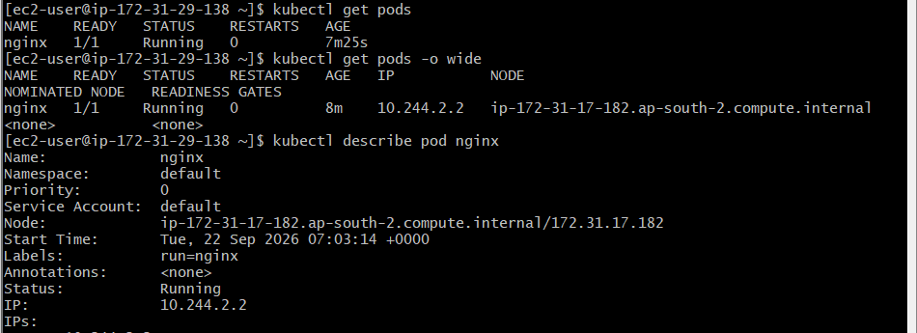
Look for:
Node:
For example:
Node: ip-172-31-17-144...
That means:
NGINX Pod
↓
Scheduled by kube-scheduler
↓
Worker 1
↓
kubelet manages it
↓
containerd runs the container
This connects the theory to your actual lab. 👍

Step 6 — Verify Container Runtime
On Worker 1 or Worker 2:
sudo systemctl status containerd --no-pager
Expected:
Active: active (running)
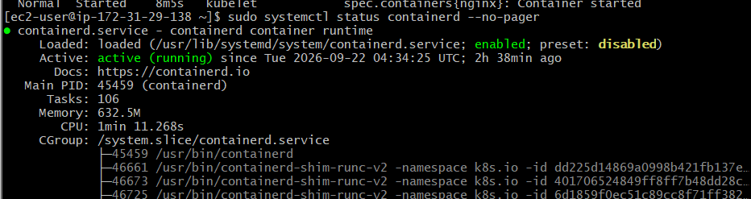
You can also run:
sudo crictl info
Your container runtime is:
Containerd

Step 7 — Final Task 4 Checklist
You should now be able to explain:
Control Plane
CONTROL PLANE
│
┌───────────────┼───────────────┐
│ │ │
API Server etcd Scheduler
│
│
Controller Manager
Worker
WORKER NODE
│
┌───────────┼───────────┐
│ │ │
kubelet kube-proxy containerd
│
↓
Pods
The complete flow
kubectl
│
▼
API Server
│
├──────────► etcd
│
▼
Scheduler
│
▼
Worker Node
│
├── kubelet
│ │
│ ▼
│ containerd
│ │
│ ▼
│ Pod
│
└── kube-proxy
│
▼
Service Network

